**POWER BI ASSIGNMENT 2**

1. Explain Web Front End(WFE) cluster from Power BI Service Architecture?

The Power BI service is built on **Azure**, Microsoft’s cloud computing infrastructure and platform. The architecture of the Power BI service is based on two clusters:

* The Web Front End (**WFE**) cluster. The **WFE** cluster manages the initial connection and authentication to the Power BI service.
* The **Back-End** cluster. Once authenticated, the **Back-End** handles all subsequent user interactions. Power BI uses Azure Active Directory (Azure AD) to store and manage user identities.

The **WFE** cluster uses Azure AD to authenticate clients, and provide tokens for subsequent client connections to the Power BI service. Power BI uses the **Azure Traffic Manager** (Traffic Manager) to direct user traffic to the nearest datacenter. Traffic Manager directs requests using the DNS record of the client attempting to connect, authenticate, and to download static content and files. Power BI uses the **Azure Content Delivery Network** (CDN) to efficiently distribute the necessary static content and files to users based on geographical locale.

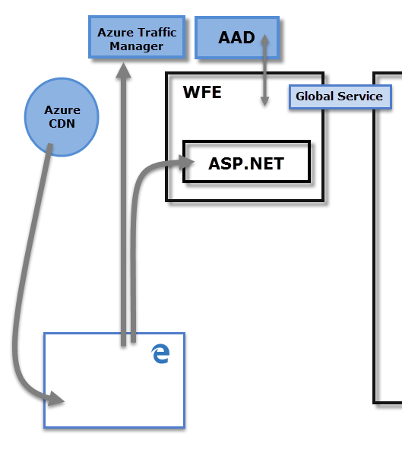

1. Explain Back End cluster from Power BI Service Architecture?

The **Back-End** cluster determines how authenticated clients interact with the Power BI service. The **Back-End** cluster manages visualizations, user dashboards, datasets, reports, data storage, data connections, data refresh, and other aspects of interacting with the Power BI service. The **Gateway Role** acts as a gateway between user requests and the Power BI service. Users don't interact directly with any roles other than the **Gateway Role**. **Azure API Management** eventually handles the **Gateway Role**.

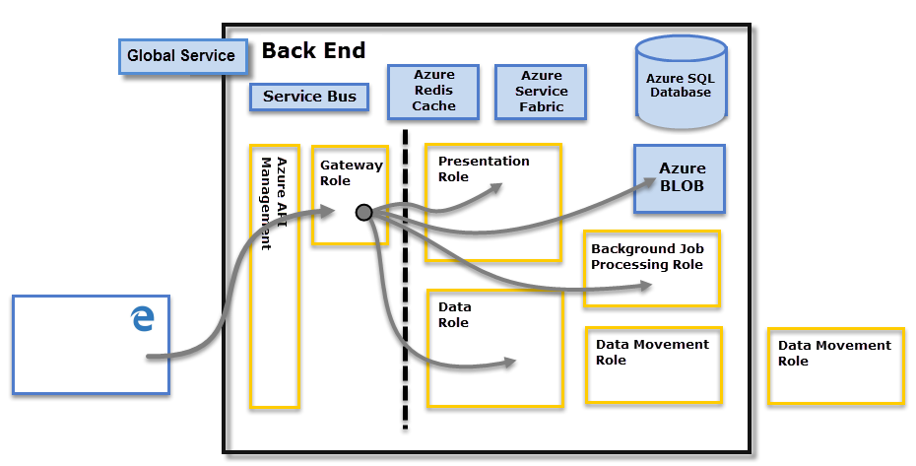

1. What ASP.NET component does in Power BI Service Architecture?

The Power BI service is built on Azure, Microsoft's cloud computing platform. Power BI is currently deployed in many datacenters around the world – there are many active deployments made available to customers in the regions served by those datacenters, and an equal number of passive deployments that serve as backups for each active deployment.

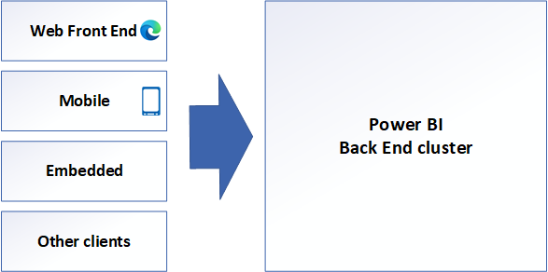

The WFE cluster provides the user's browser with the initial HTML page contents on site load, as well as pointers to CDN content used to render the site in the browser.

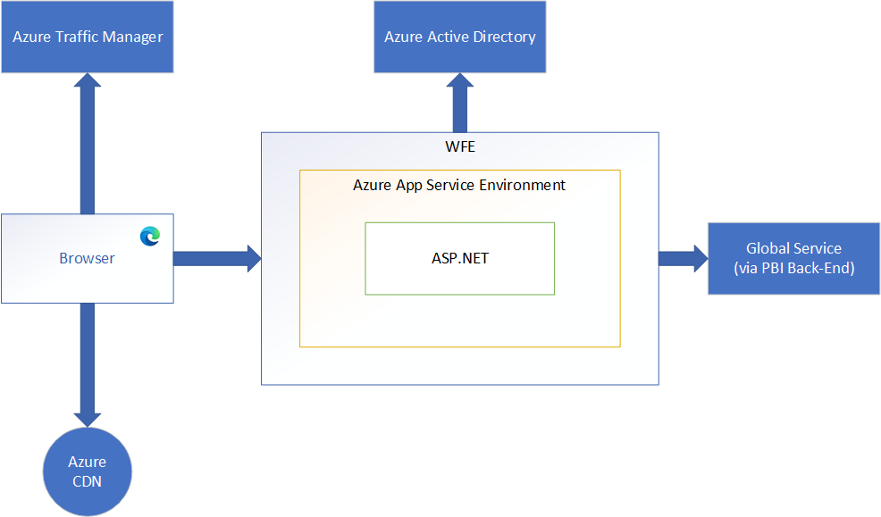

A WFE cluster consists of an ASP.NET website running in the Azure App Service Environment. When users attempt to connect to the Power BI service, the client's DNS service may communicate with the Azure Traffic Manager to find the most appropriate (usually nearest) datacenter with a Power BI deployment. For more information about this process, see  Performance traffic-routing method for Azure Traffic Manager.

Static resources such as *.js, *.css, and image files are mostly stored on Azure Content Delivery Network (CDN) and retrieved directly by the browser. Note that Sovereign Government cluster deployments are an exception to this rule, and for compliance reasons will omit the CDN and instead use a WFE cluster from a compliant region for hosting static content.

1. Compare Microsoft Excel and Power BI Desktop on the following features:

Data Import : Microsoft Excel has limited connectivity with other applications and systems, whereas Microsoft Power BI can extract data from virtually any platform, software and application.

Data Transformation : With the hep of Power Query we can transform our data Power BI, this means removing errors, modifying layout and making the data more useful. In Microsoft Excel we can import or connect to external data, and then *shape* that data, for example remove a column, change a data type, or merge tables, in ways that meet your needs. Then, you can load your query into Excel to create charts and reports.

Modeling : Excel has the ability to work on simple and structured data models on the other hand Power BI id ideal for building complex data models easily.

Reports : Excel has simpler and less attractive reports & Power BI has more beautiful, personalized, attractive and interactive reports.

Convert Models : Power BI has a wide variety of visualizations. We can import many other visuals from the marketplace besides available built-in charts. Excel has only a few built-in charts, and we need to work with only those charts to build dashboards.

Server Deployment : Once the dashboard building completes in Power BI, we can publish the report to the end-users with Microsoft’s cloud-based services. But, when it comes to Excel, we need to share the large data with the dashboard via email or any online sharing tool.

Cost : Power BI Desktop is free to download and use for personal use, but it takes  $10 per month per user to share reports with others. In Microsoft Excel we need to spend additional money to procure this and build dashboards.

1. List 20 data sources supported by Power BI desktop.

* Excel Workbook
* Text/CSV
* XML
* JSON
* Folder
* PDF
* Parquet
* SharePoint folder
* SQL Server database
* Access database
* SQL Server Analysis Services database
* Oracle database
* IBM Db2 database
* IBM Informix database (Beta)
* MySQL database
* PostgreSQL database
* SAP Business Warehouse Application Server
* SAP Business Warehouse Message Server
* Amazon Redshift
* BI Connector
* Data Virtuality LDW